|  |  |
| --- | --- |
|  | **Web Designing Assignment**  **Module (HTML5) – 3** |

1. **What are the new tags added in HTML5?**

**Ans:**New elements are added in HTML5 to write easy and fast code to create complex, dynamic, engaging, and effective websites. These new elements add advanced functional features, improvised page layouts, and other improvements. The commonly used new HTML5 tags are <figure>, <article>, <header>, <main>,<footer>, <nav>, and <section>.

1. **How to embed audio and video in a webpage?**

**Ans: For audio:** To embed audio in HTML, we use the <audio> tag. To play audio, we used web plugins like Flash. This tag supports Chrome, Firefox, Safari, Opera, and Edge in three audio formats – MP3, WAV, OGG.

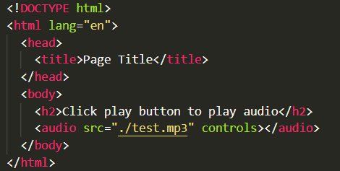

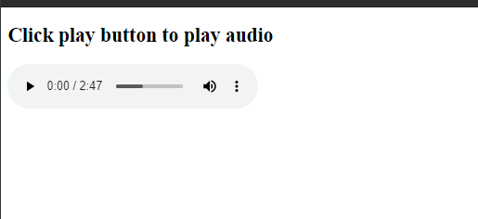

**For Video:** To embed video in HTML, we use the <video> tag. It contains one or more video sources at a time using <source> tag. It supports MP4, WebM, and Ogg in all modern browsers.

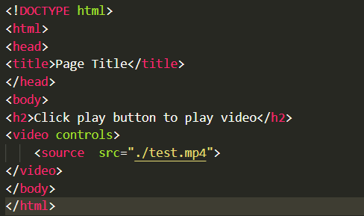



1. **Semantic element in HTML5?**

**Ans:**  Semantic elements have meaningful names that tell about the type of content. For example header, footer, table, … etc. HTML5 introduces many semantic elements as mentioned below which make the code easier to write and understand for the developer as well as instruct the browser on how to treat them.

|  |  |
| --- | --- |
| [**<article>**](https://www.geeksforgeeks.org/html5-article-tag/) | [**<footer>**](https://www.geeksforgeeks.org/html5-footer-tag/) |
| [**<aside>**](https://www.geeksforgeeks.org/html5-aside-tag/) | [**<header>**](https://www.geeksforgeeks.org/html5-header-tag/) |
| [**<details>**](https://www.geeksforgeeks.org/html5-details-tag/) | [**<main>**](https://www.geeksforgeeks.org/html-main-tag/) |
| [**<figcaption>**](https://www.geeksforgeeks.org/html5-figcaption-tag/) | [**<mark>**](https://www.geeksforgeeks.org/html-mark-tag/) |
| [**<figure>**](https://www.geeksforgeeks.org/html5-figure-tag/) | [**<nav>**](https://www.geeksforgeeks.org/html-nav-tag/) |
|  | [**<section>**](https://www.geeksforgeeks.org/html-section-tag/) |

1. **Canvas and SVG tags**

**Ans:** SVG is a language for describing 2D graphics in XML. Canvas draws 2D graphics, on the fly (with JavaScript). SVG is XML based, which means that every element is available within the SVG DOM. You can attach JavaScript event handlers for an element. In SVG, each drawn shape is remembered as an object.

|  |  |
| --- | --- |
| **Canvas** | **SVG** |
| **Resolution dependent** | **Resolution independent** |
| **No support for event handlers** | **Support for event handlers** |
| **Poor text rendering capabilities** | **Good text rendering capabilities** |
| **You can save the resulting image as .png or .jpg** | **Slow rendering if complex (anything that uses the DOM a lot will be slow)** |
| **Well suited for graphic-intensive games** | **Not suited for game applications** |